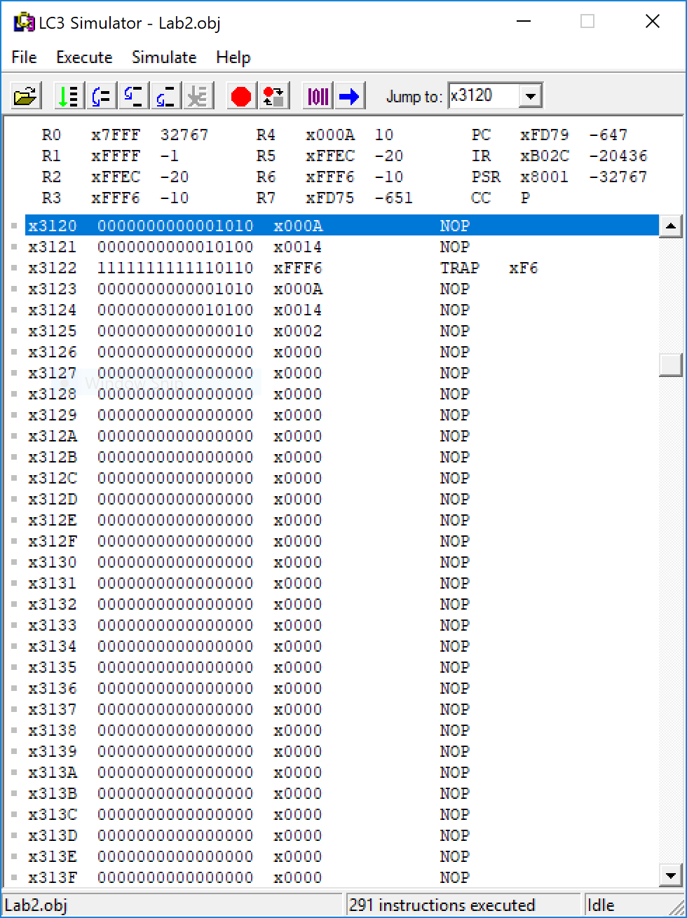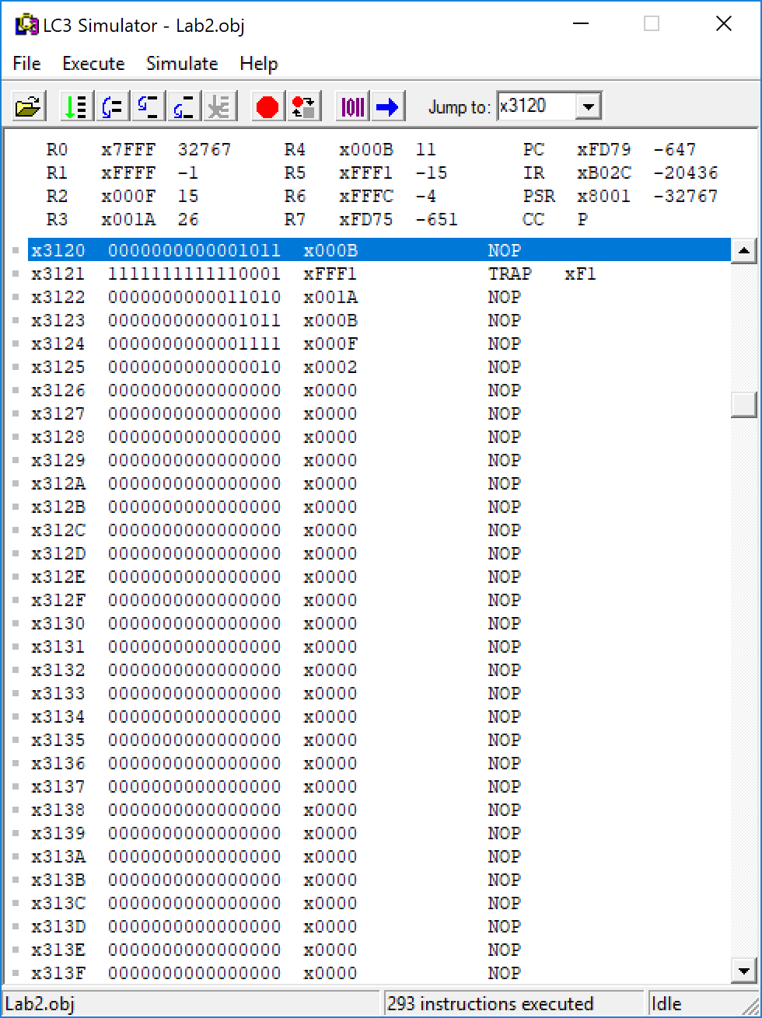Hector Diaz Flores

004854001

Lab 2 Proof

(X,Y) Pair (10,20)

(X,Y) Pair (11, -15)

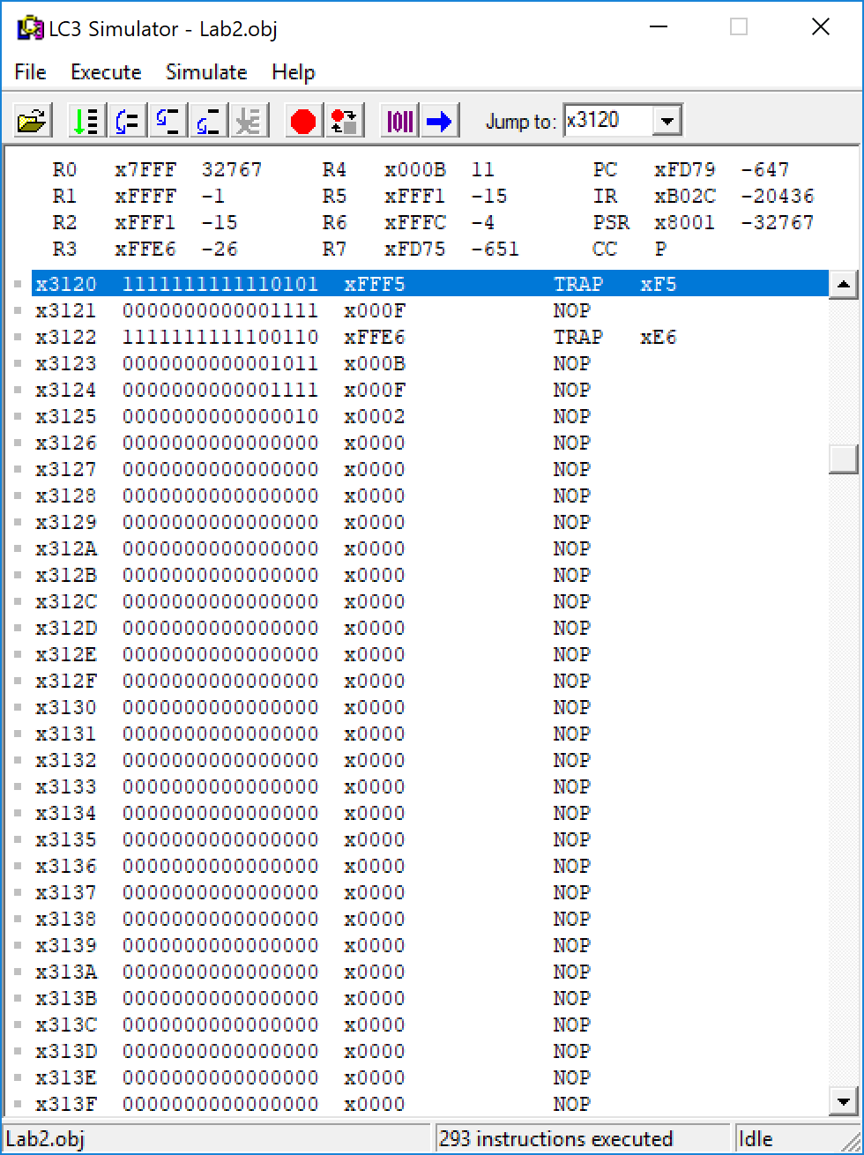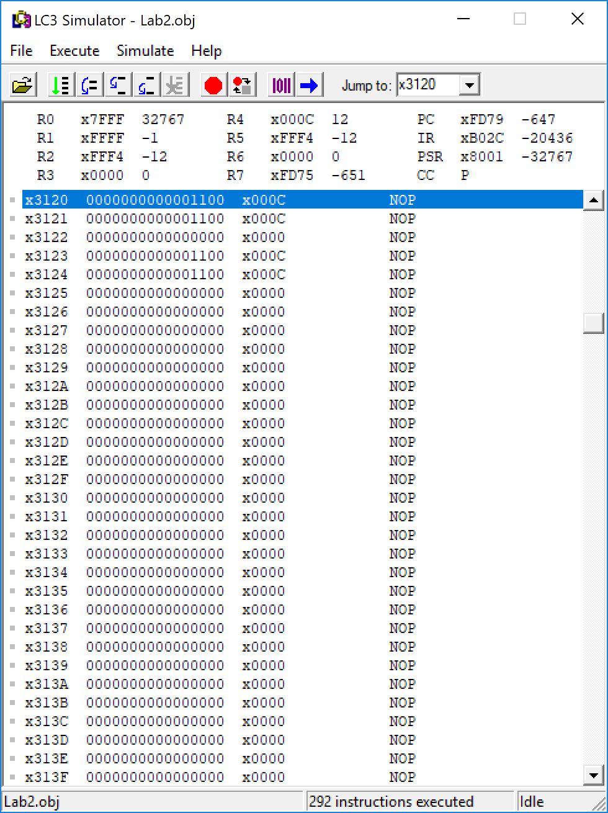(X,Y) Pair (-11, 15)

(X,Y) Pair (-11, 15)